CM4025 - Enterprise Web Development

Link to GitHub: <https://github.com/DanyalXD/myGame>

Link to Video: <https://www.youtube.com/watch?v=Bmjx7TXgd_w&feature=youtu.be>

# Design

### Game Functionality

* Login Screen
* Be able to register users
* Select Player type
* Create multiplayer game rooms
* 1 on 1 combat
* Chat feature
* Some sort of projectile

## Story Boards

Login Page;

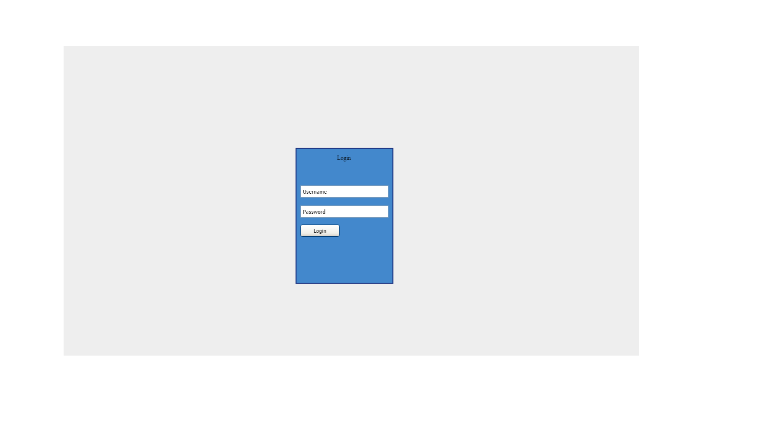

Pick Character Screen;

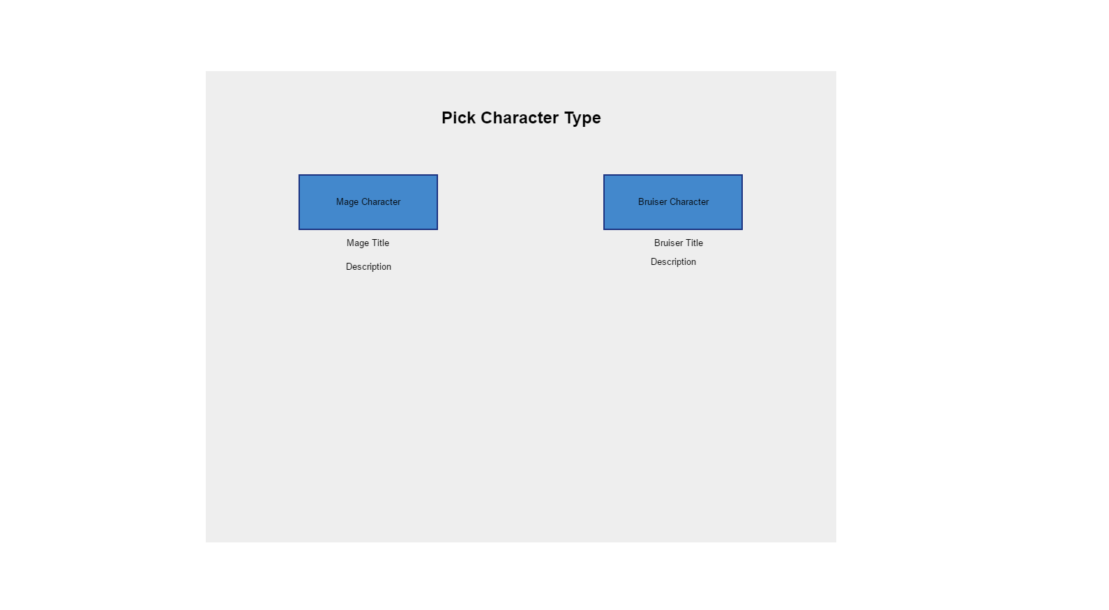

Game Screen;

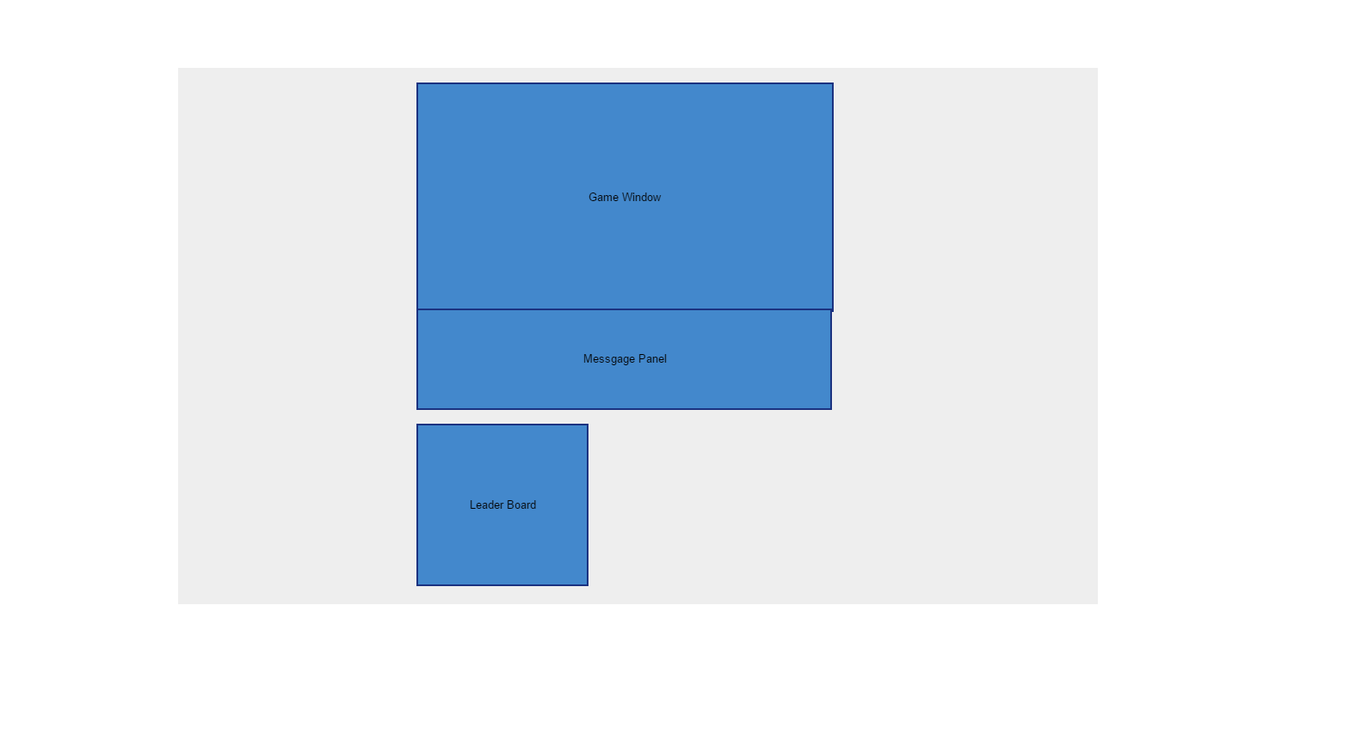

Instructions;

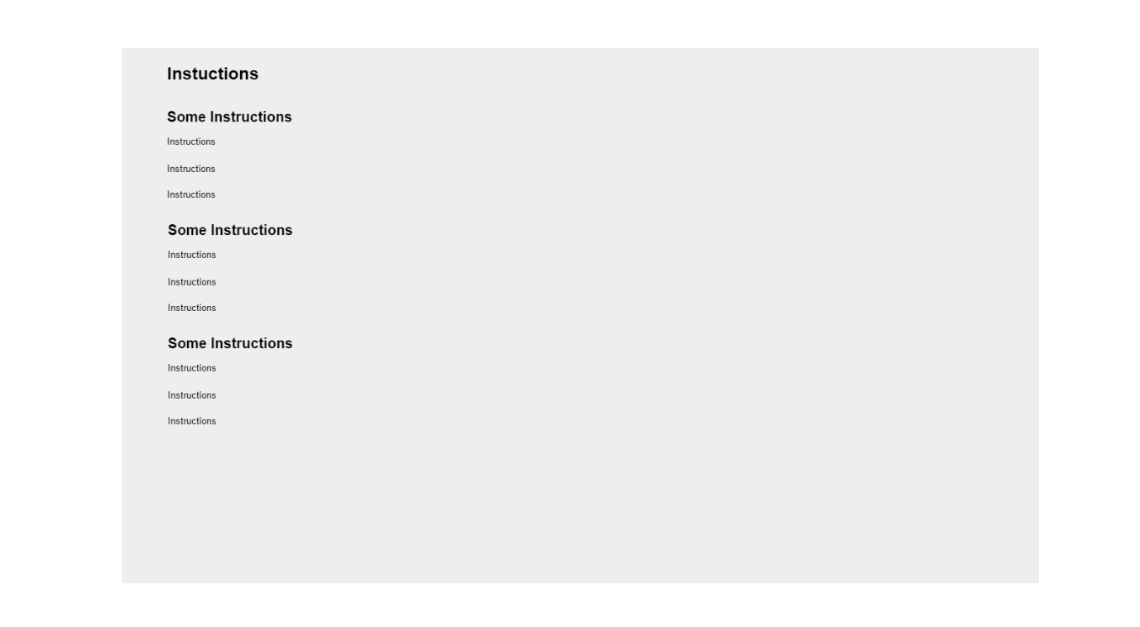

# Game and Screen Shots

The game is called Heroes of Magic. You can pick which champ you want to be dps mag or bruiser mage. Champions can battle 1v1 or have multiple players in a battle. The player gains xp by slaying a player in battle. Depending on player type will depend on the players ulti.

Login;

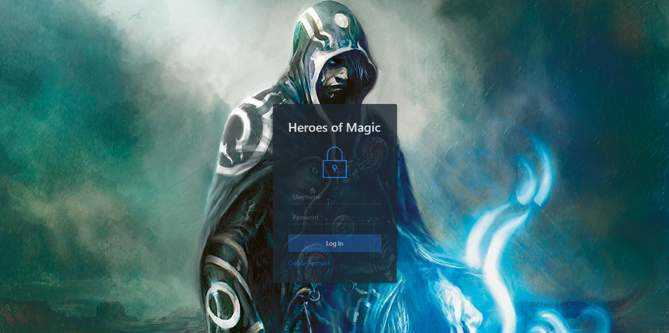

Pick Character Screen;

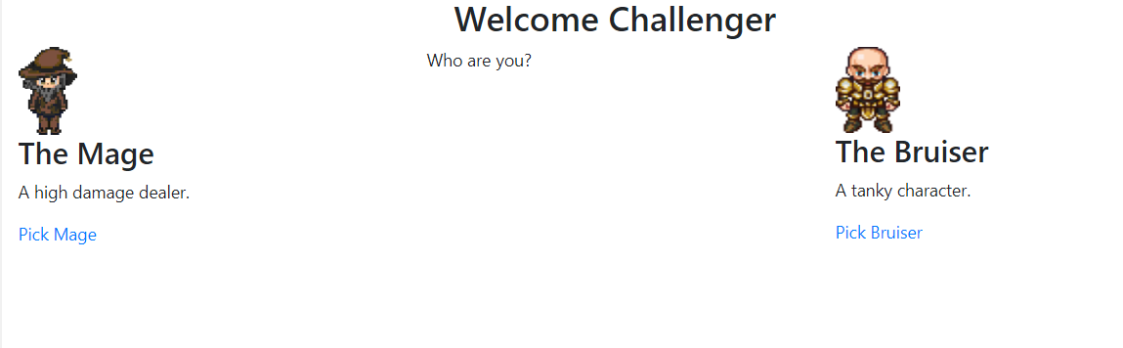

Game Screen;

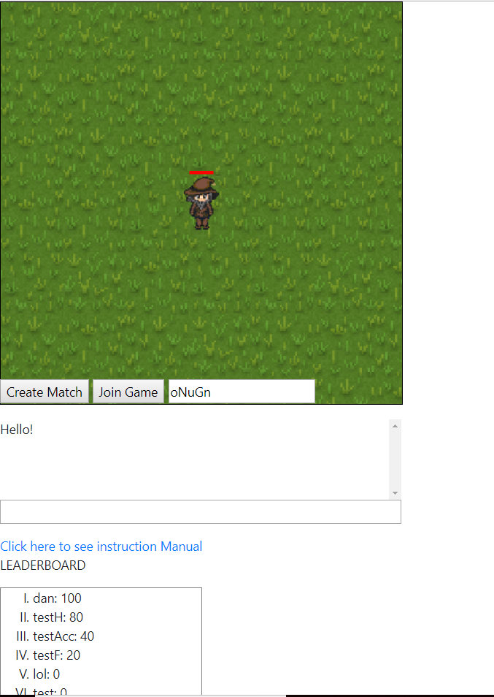

Instructions;

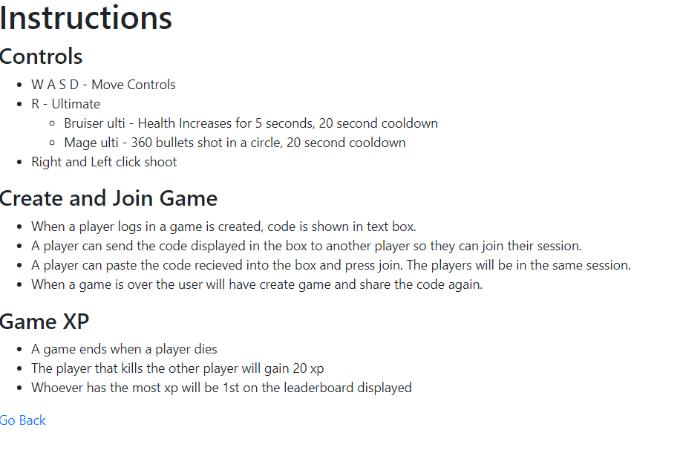

# Testing

|  |  |  |
| --- | --- | --- |
| Test | Expected Output | Actual Output |
| Create a user | A user is created | A User is Created |
| Login | A user logs in | A user logs in |
| Select a champ type | Champion type selected | Champion type selected |
| Press WASD to move directions | Champion moves | Champion moves |
| Press R to use ultimate | Ultimate used | Ultimate used |
| Ultimate goes on cooldown after user | Ultimate goes on cooldown after user | Ultimate goes on cooldown after user |
| Left and right click to shoot | Champion shoots | Champion shoots |
| Send Message in chat | A message is sent in chat | A message is sent in chat |
| Leaderboard appears on login | Leader board appears on login | Leader board appears on login |
| Refresh Leaderboard | Leaderboard refreshed | Leaderboard refreshed |
| Click create game | A game is created and the code is displayed in the input box | A game is created and the code is displayed in the input box |
| Join game with code given by another user | A player joins the users game | A player joins the users game |